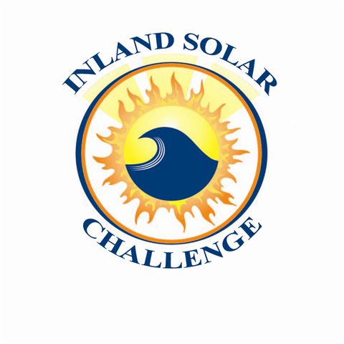
ISC Meeting Agenda
Boat Build Meeting with ISC Teachers
Date | time 11/5/2022 8:30 AM Location YVWD

Agenda Items
- Welcome and Introductions
- Banning High School – Larry Ellis
- Desert Hot Springs High School – Casey Heiser
- Palm Springs High School - Rory Pratt
- Colton High School – Chris Barth, Daniel Hearon
- Cajon – Roger Light, Erick Henderson
- Indian Springs – Chelsea Mackie
- Rialto High School – Mikal Thompson
- Desert Mirage – Matt Kreps
- Approve Minutes from Teacher Meeting (9/22)
  - Janett moved to approve, Cecilia G. seconded
- PSA Prompt
  - Mary Jo explained PSA prompt, asked if there were any questions
  - Teachers/advisors had no questions
- Rule Discussion
    - Mary Jo provided the new rule packet to attendees and advised them that it is also on the website
    - Mary Jo gave recap of previous teacher meeting and discussed agreed upon rules for battery boxes and psa scoring

- Timeline of Events
  - Mary Jo provided timeline
  - Group discussed timeline
  - Casey Hesier, DHSHS, asked if the committee would consider moving the ISC event date to another week in May
- Race/PSA Order
- Mary Jo explained that because Desert Mirage was added after the race orders were chosen that committee had agreed they would go last
- Desert Mirage and other schools agreed to adding DMHS last in the race and psa orders

- Misc. Questions/Discussions
  - No questions

